**Java Rice**

**An Interactive Food Ordering System**

@JRTeam2023

About Us:



**Kurt Daniel S. Cano**



**Mike Rufino J. Caram II**



**Joshua O. Lonoza**

**Kevin A. Llanes**



**Jhon Keneth Ryan B. Namias**

"Now you'll Meat your End." -Vergil

Table of Contents:

Contents

About Us: 1

Table of Contents: 2

I. Introduction: 3

II. Objectives: 3

III. Methodology: 3

IV. Timeline: 3

V. Limitations: 3

VI. Criteria: 3

VII. Conclusion: 3

VIII. References: 4

IX. Appendix: 4

X. Flowchart: 4

XI. Development 5

Alpha Build: 5

i. UI Design: 5

ii. Database: 9

iii. Forms: 10

iv. Functions: 10

v. Color Palette: 10

I. Introduction:

Java Rice is a food ordering system designed to make the process of ordering food easier for users. The system is built using Java and Maven GUI, which provides an interactive and user-friendly experience. The purpose of this system is to allow users to order their favorite meals with ease and convenience.

II. Objectives:

* To provide a platform where users can order food with just a few clicks.
* To make the process of food ordering fast and efficient.
* To provide users with an interactive and user-friendly experience.
* To provide a secure and reliable platform for food ordering.

III. Methodology:

* The system will be built using Java programming language and Maven GUI for the front-end interface.
* A database will be used to store all the information about the food items and orders.
* The system will provide a user-friendly interface for users to place their orders.
* The system will use secure payment methods to process the transactions.

IV. Timeline:

* Planning and Design Phase: 2 weeks
* Development Phase: 4 weeks
* Testing and Debugging Phase: 2 weeks
* Deployment Phase: 1 week

V. Limitations:

* The system will only be available for use on devices with Java and Maven GUI installed.
* The system will only support online payment methods.
* The system will not provide delivery services.

VI. Criteria:

* Usability
* Availability
* Reliability
* Maintainability
* Security

VII. Conclusion:

Java Rice is a food ordering system designed to provide users with a fast and convenient way to order food. The system is built using Java and Maven GUI, which provides an interactive and user-friendly experience. The system will provide a secure platform for food ordering and will be accessible on devices with Java and Maven GUI installed. The estimated timeline is 9 weeks.

VIII. References:

* Java Programming Language Reference: Oracle Corporation
* Maven GUI Reference: Apache Software Foundation
* <https://PP-Namias.Github.io/Java-GUI/>

IX. Appendix:

* Detailed project plan
* Technical specifications
* UI Design
* Database
* Functions
* Color Palette

X. Flowchart:

XI. Development

Alpha Build:

i. UI Design:

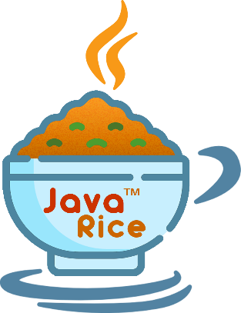

Java Rice Logo [Transparent]



Java Rice Banner with Logo [Transparent]



Java Rice Banner [Transparent]

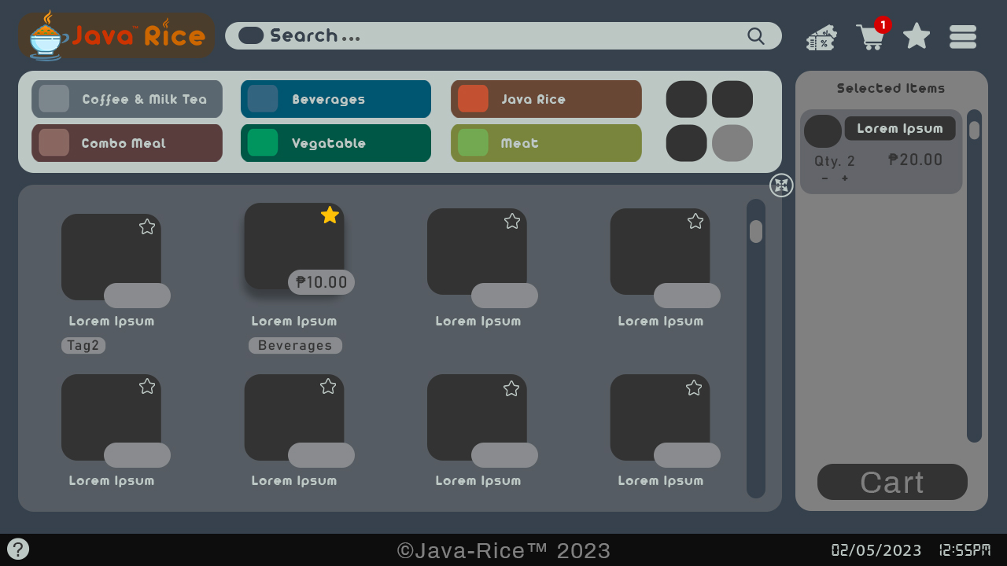

Java Rice Main Form [Regular]

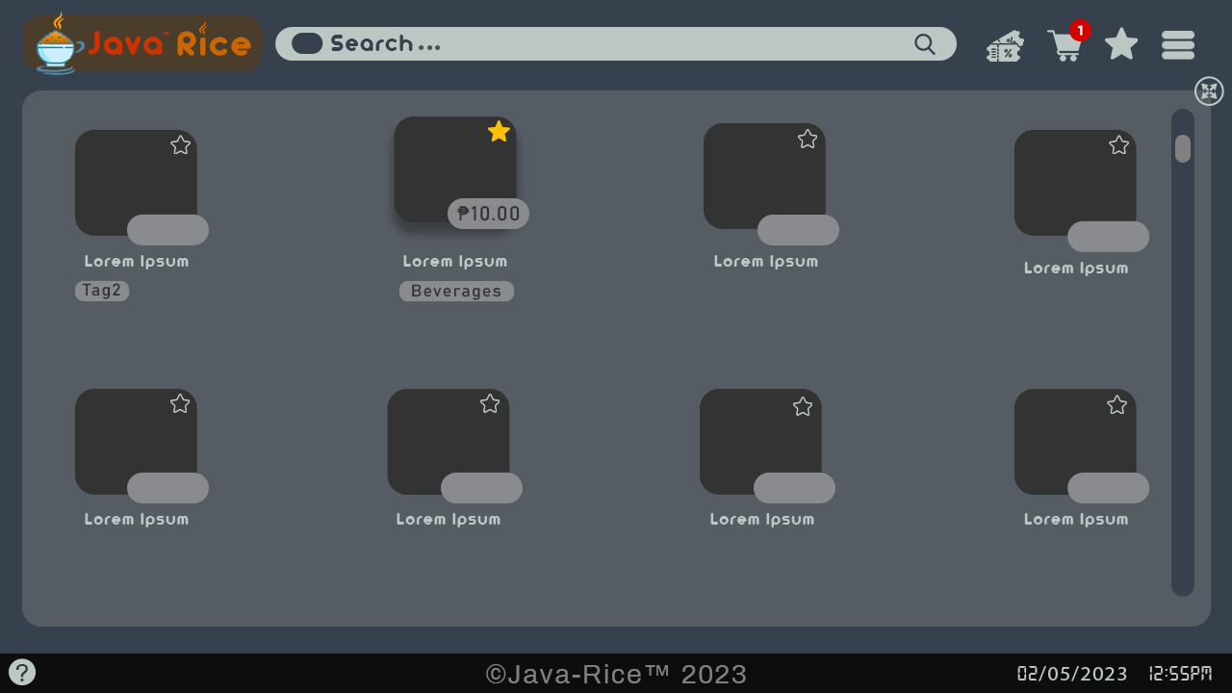

Java Rice Main Form [Maximize]

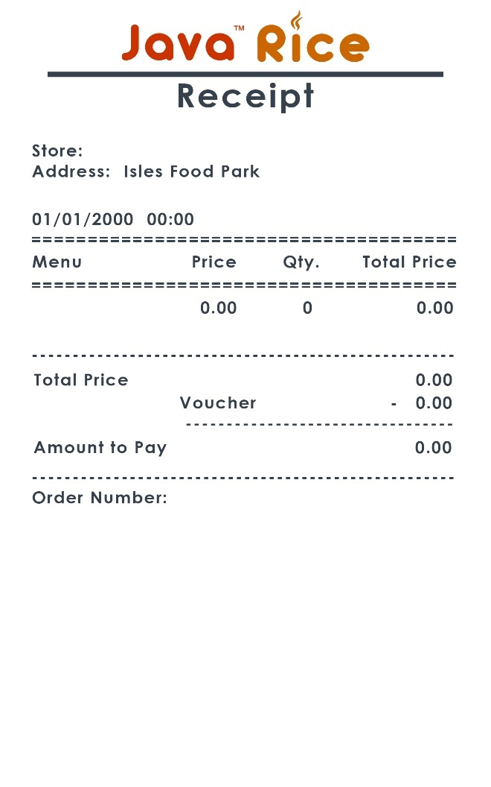

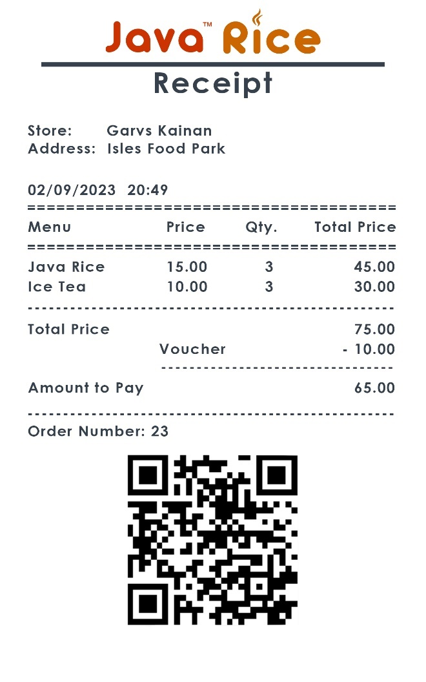

Java Rice Receipt [Default]

Java Rice Receipt [Example]

ii. Database:

**Main**

* **Product_num** = increment > not null > auto
* **Name** = string
* **Category** = string
* **Store_num** = int > no repeat
* **Price** = long double
* **Image** = obj
* **Favorite** = bool

**Selected_items**

* **Product_num** = increment > not null > auto
* **Name** = string
* **Category** = string
* **Store_num** = int > no repeat
* **Price** = long double
* **Image** = obj
* **Quantity** = number
* **Voucher** = string
* **Discount** = double

**Ordered_items**

* **Order_num** = increment > not null > auto
* **Product_num** = not null > auto
* **Name** = string
* **Category** = string
* **Store_num** = int > no repeat
* **Price** = long double
* **Image** = obj
* **Quantity** = number
* **Voucher** = string
* **Discount** = double

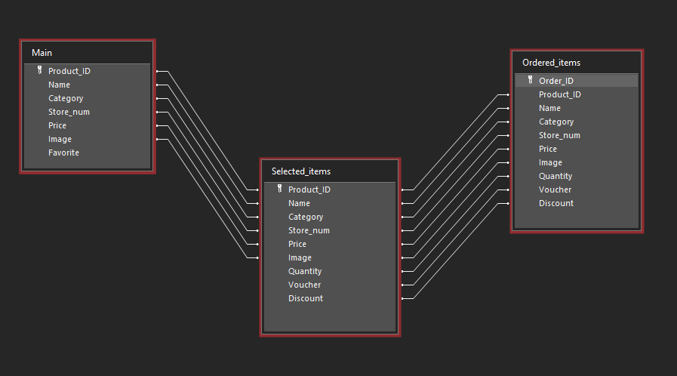

iii. Forms:

* **MainForm**
* **Cashier**
* **Receipt**

iv. Functions:

* Ordering system [multiple selections]
* Auto-generated search bar
* Receipt
* Order logs
* Items order
* Order number
* QR Code [generator] [reader]
* Voucher Discounts

v. Color Palette:

* **Main Background:** #36414d
* **Foreground:** #898b8e
* **Text (Dark):** #36414d // Light Background
* **Text (Light):** #bcc7c4 // Dark Background
* **Other:**
  + #333333
  + #5182a1
* **Cart:** #808080
  + #63656a
* **Footer:** #0d0d0d
* **Logo:**
  + #cc3300 // Java
  + #cc6600 // Rice